KIMFAY PROFESSIONAL
Workflow and Requirements Document
Including Process Flowcharts for All Core Workflows
April 2026

Table of Contents
1. Introduction 1
2. Key Areas of Focus 1
3. Detailed Requirements and Workflows 1
3.1 Meeting Management and Scheduling 1
3.2 Order Management 1
3.3 Payment Management 1
3.4 Price Change Request Workflow 1
3.5 Free on Loan (FOL) Dispenser Approval Workflow 1

1. Introduction
Overview of the HORECA Business-to-Business (B2B) operational requirements and proposed workflow enhancements. The primary objective is to optimize processes, enhance operational efficiency, and provide clear visibility for management decision-making. This revision specifically integrates the Free on Loan (FOL) Dispenser approval process with the existing Price Change Request workflow, ensuring a cohesive approach to critical business operations.
Each core workflow in Section 3 is accompanied by a process flowchart that illustrates the end-to-end flow of activities, decision points, and system touchpoints.

2. Key Areas of Focus
The strategic areas identified for improvement and automation, based on the provided requirements, include:
- Meeting Management and Scheduling: Streamlining the planning, execution, and tracking of sales and service meetings.
- Order Management and Follow-up: Enhancing the entire order lifecycle, from suggestion to fulfillment.
- Payment Management and Collections: Optimizing processes for payment tracking and collection efforts.
- Price Change Request Workflow: Establishing a clear, approval-based process for price adjustments.
- Free on Loan (FOL) Dispenser Approval Workflow: Defining a structured process for dispenser requests and approvals.
- Reporting and Analytics: Developing automated reporting mechanisms for critical business insights.
- ERP Integration: Ensuring seamless data flow and operational synergy with the Enterprise Resource Planning system.
- Team Management and Activities Tracking: Monitoring and managing team performance and daily activities.
- Customer Relationship Management (CRM) Aspects: Incorporating features for notes, surveys, returns, and asset management.

3. Detailed Requirements and Workflows

3.1 Meeting Management and Scheduling
The current manual journey planning aims for a minimum of four meetings per day. The enhanced system will focus on automating and tracking these activities.

Feature | Description
Meeting Frequency | Minimum of 4 meetings per day per team member.
Meeting Purpose | Capture the specific reasons for each meeting to ensure alignment with business objectives.
Visitation Scheduling | Implement a robust system for scheduling and managing regular customer visits and follow-ups.
Location Tracking | Utilize GPS-based tracking for team members during meetings to verify attendance and optimize routes.
Meeting Output Capture | Standardize the capture of key information from each meeting, typically through four structured questions.
Action Item Tracking | Enable the ability to review and track action items from previous meetings, ensuring accountability and continuity.
Performance Reporting | Generate reports on the number of meetings conducted and the status of action items (closed vs. pending).
Automated Scheduler | Develop an automated scheduler to facilitate efficient visitation planning.
Planned Journey Plan (PJP) | Transition from manual journey planning to an automated PJP system, targeting four meetings daily for each team member.

3.1.1 Workflow Flowchart
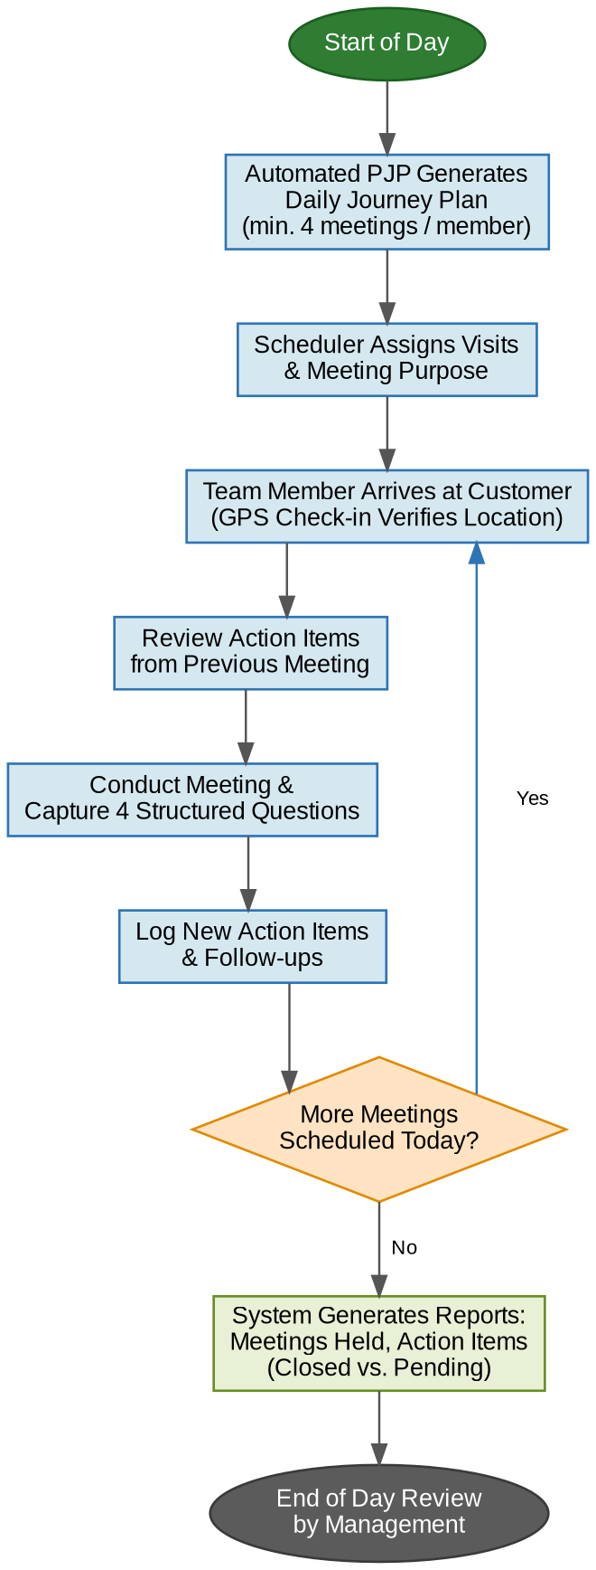
Figure 1: Meeting Management and Scheduling (Automated PJP) Workflow

3.2 Order Management
Order management encompasses the entire process from initial suggestions to fulfillment, addressing the dynamic nature of client demands.
Feature | Description
Order Suggestions | Implement a system to provide intelligent order suggestions based on historical data or customer profiles.
Order Follow-up | Systematize the follow-up process for all orders to ensure timely delivery and customer satisfaction.
Order Booking | Facilitate order booking primarily via Local Purchase Orders (LPO).
Order Fulfillment Tracking | Provide visibility into the progress of orders within 1-2 window from the order date (in case where we have backorders, account onhold)
Dynamic Quantity Handling | The system must accommodate variations in order quantities and frequent client changes.
Sales Metrics Tracking | Monitor and report on opportunities, lead closings, Value-Added Services (VAS), and range selling performance.

3.2.1 Workflow Flowchart
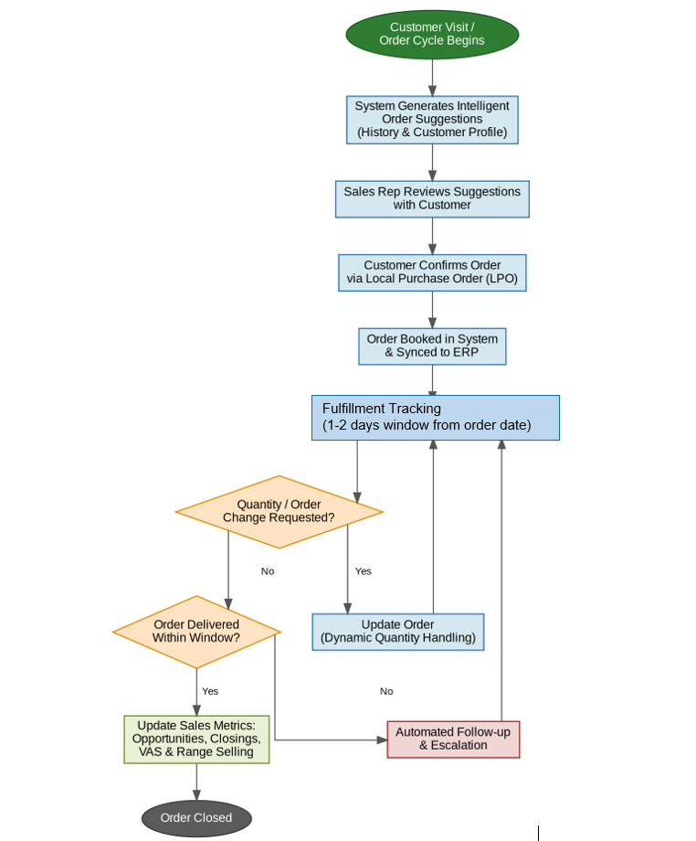
Figure 2: Order Management Workflow (Suggestion to Fulfillment)

3.3 Payment Management
Effective payment management is crucial for maintaining healthy cash flow and customer relationships.
Feature | Description
Payment Follow-up | Systematize the follow-up process for outstanding payments.
Credit Customer Management | Implement robust management tools for credit customers, including credit limits and payment terms.
Collection Push Mechanisms | Develop and integrate mechanisms to facilitate and expedite payment collections.

3.3.1 Workflow Flowchart
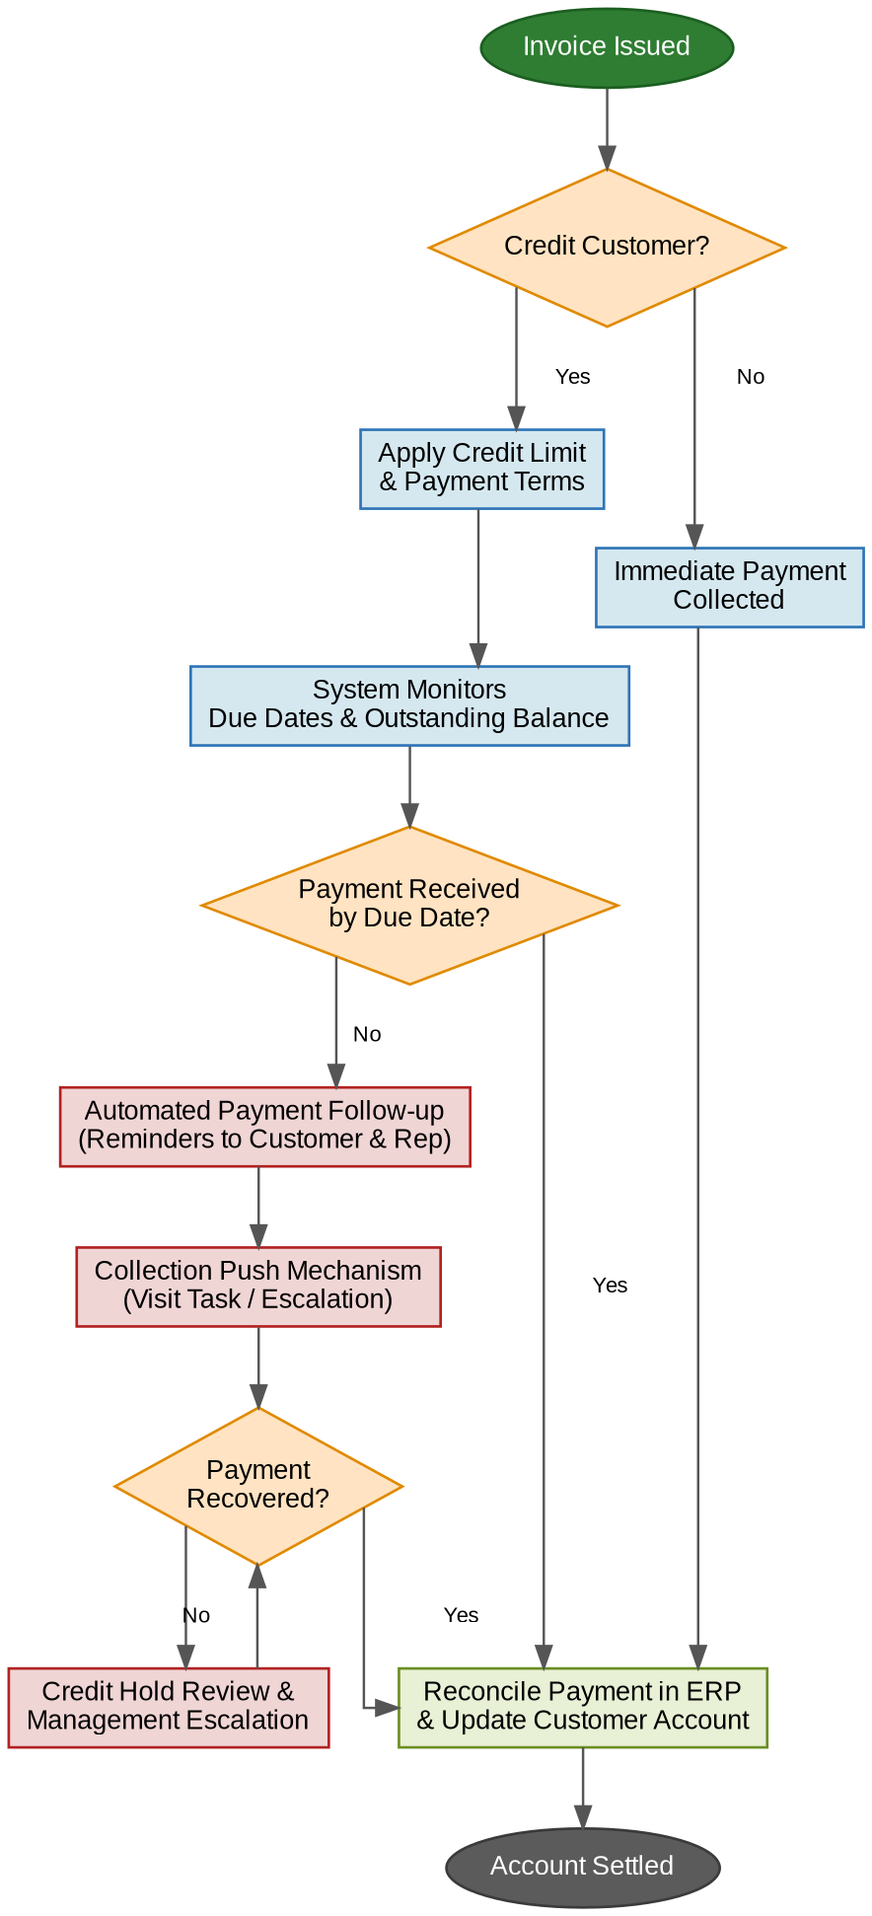
Figure 3: Payment Management and Collections Workflow

3.4 Price Change Request Workflow
This workflow is designed to manage customer-initiated price change requests efficiently and with appropriate approvals. The process ensures every price adjustment is justified, reviewed against margin impact, approved at the correct level of authority, and recorded with a full audit trail.
Step | Actor | Action
1 | Customer | Requests a price change for one or more products.
2 | Sales Representative | Submits a Price Change Request in the system, capturing the customer, product/SKU, current price, proposed price, and business justification.
3 | Line Manager | Reviews the request, assessing the commercial justification and margin impact.
4 | Line Manager / Senior Management | If the change is within the manager's approval threshold, the manager approves or rejects. If it exceeds the threshold, the request is escalated to senior management for a decision.
5 | System (ERP) | On approval, the new price is updated in the ERP with an effective date, and an audit trail is recorded.
6 | System | The sales representative and customer are notified of the outcome (approval with effective date, or rejection with reason).

3.4.1 Workflow Flowchart
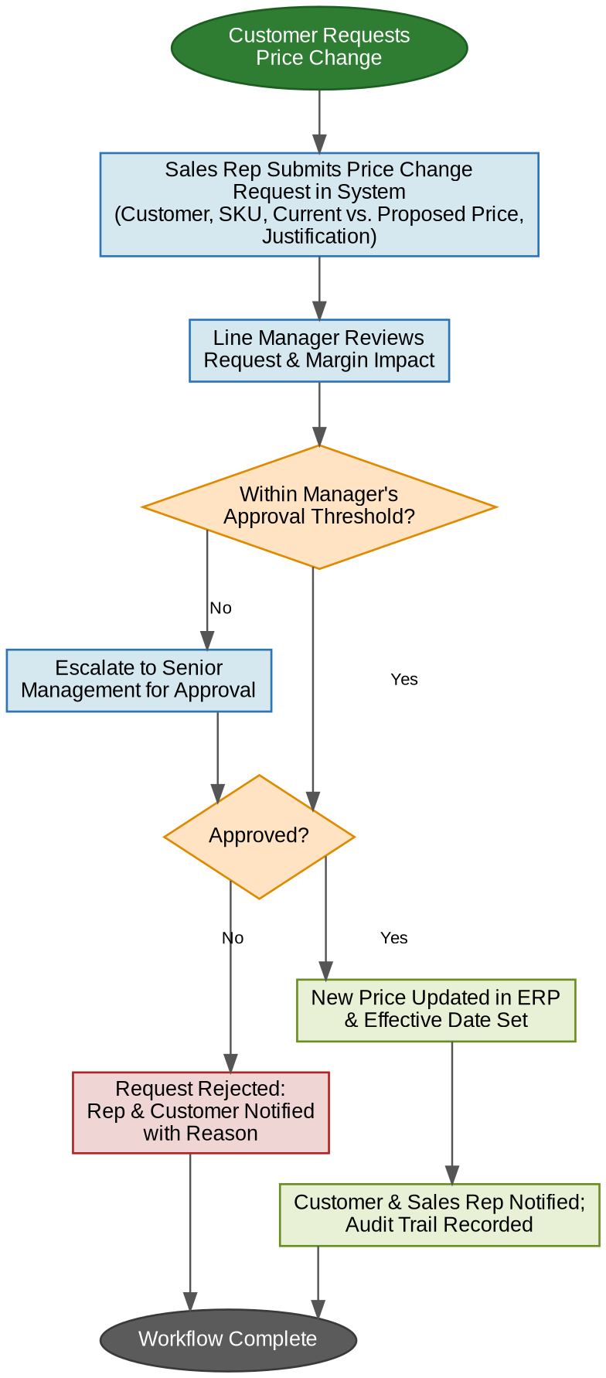
Figure 4: Price Change Request Approval Workflow

3.5 Free on Loan (FOL) Dispenser Approval Workflow
The FOL Dispenser workflow governs the placement of company-owned dispensers at customer sites on a free-on-loan basis. It is integrated with the same approval framework as the Price Change Request workflow, ensuring that asset commitments are justified by volume, approved at the right level, and tracked throughout the asset lifecycle.
Step | Actor | Action
1 | Customer | Requests a dispenser on a Free on Loan basis.
2 | Sales Representative | Submits an FOL Dispenser Request with a business case, including the expected purchase volume commitment.
3 | Manager | Reviews the request against volume justification, the customer's credit standing, and dispenser/asset availability.
4 | Manager | Approves or rejects the request. Rejections are communicated to the representative and customer with a reason.
5 | Operations / System | On approval, the dispenser is allocated as a company asset, a loan agreement is signed, and the unit is installed at the customer site and registered in asset tracking.
6 | System / Sales Team | Periodic reviews compare actual purchases against the committed volume, alongside scheduled maintenance visits.
7 | Manager | If the volume commitment is not met, a corrective action plan is agreed or a dispenser recall is initiated, with the asset status updated in the system.

3.5.1 Workflow Flowchart
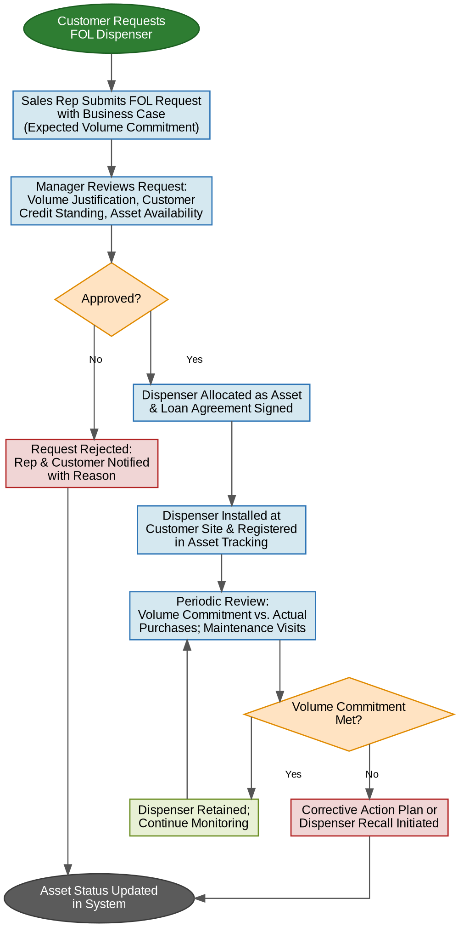
Figure 5: Free on Loan (FOL) Dispenser Approval and Asset Lifecycle Workflow

